PATH Phone User Guide

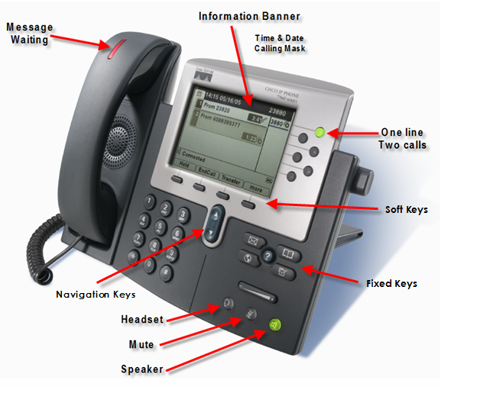
Dialing Instructions

Inter-office: Dial a 4-digit extension
Local Calls: Dial 9 + area code and number (10-digits)
Long Dist: Dial 9 + 1+ area code and number, voice will ask for account code, enter 8 digit project code

International: Dial 9 + 011 + country code + city code + number, voice will ask for account code, enter 8 digit project code

Voice Mail Outside Access: 206-298-4303

6 digit dialing to DC office: 72 + 4 digit extension number

Emergency: 9+911

To set up voicemail: Press Messages button on phone and enter password 4444.

PHONE DESCRIPTION

Information bar at top of display – Displays the Time, Date, and Primary Telephone Number.
Line Keys – Includes Primary Extension, Intercom, Shared Lines, or blank buttons available for Speed Dial
Soft Keys – In the lower part of display indicates available features: REDIAL, NEW CALL, CFWDALL (other features are optional). If you see MORE that indicates additional features to choose from. The Soft Keys change with call activity (more features to follow)
Navigation Bar – The arrows in the middle of the phone are used to scroll through menus and features
Fixed Keys – include the following:
Message Key – Press this button as a shortcut to reach Voice Mail. Default password is 4444.
Settings Key – Press the SETTINGS button, then SELECT (soft key) button for User Preferences
To change Ring Type – Press SELECT for Ring Type, press SELECT (soft key) Default ring to change ring type for all lines on phone, or scroll down to change ring type by line. Scroll through the variety of ring types, press PLAY to hear each one, and press SELECT, then OK to Save it.
To change the Brightness OR Contrast – Scroll down to SELECT Contrast. Use the UP or DOWN soft keys to adjust the contrast and press SAVE and then EXIT.
Directories – To view Received, Placed or Missed Calls and look up an employee in the Corporate Directory Scroll to select directory desired. View numbers, edit numbers or dial numbers you see in the display. Caution: The Clear key erases all the numbers except in the Corporate Directory
Services – Shows features that are subscribed to this phone. For example: Fast Dials or My Address Book. These Directories are setup at the CCM User page (more info to follow)
Help ? Key – Press the ? button and wait for a help directory, or press any key to display help for that key.
Volume Control – for HANDSET, HEADSET, SPEAKERPHONE, or RINGER VOLUME. Use the horizontal volume bar on lower right of the phone. The volume control adjusts the volume for the current active condition. To save the setting, press SAVE. When the phone is idle it controls the ringing volume. Caution: Be careful not to turn the ringer completely off.
Speaker Key – This button toggles the Speaker phone on and off.
Mute Key – This button toggles the microphone on and off when using the Speaker, Handset or Headset. When the light is Red, the caller cannot hear you. When the light is off you can be heard again.
Basic Operations – are described here:
Place a Phone Call – Lift the Handset or press SPEAKER or press NEW CALL soft key or Pre-Dial the number, then press the DIAL soft key.
Answer a Call – Caller ID will show in the display. Lift the Handset, or press SPEAKER or press the ANSWER soft key if another call is presented or you are using a Headset.
Call Waiting – If you have a second incoming call, you will hear a call waiting tone in your ear. Ask the current caller to hold, then press the ANSWER soft key and the1st call is automatically put on hold. To go back and forth between callers, use the Navigation (up/down arrows) to scroll to each call and press RESUME soft key to connect to specific caller.
Soft Keys – include the following:
more – Will appear as the right-most soft key when there are more than four soft key features available at the time. Press this button to view the next set of softkeys. After pressing more, if no further selection is made, the initial softkeys will return after five seconds.
[Hold] Place a Call on Hold – Press the HOLD soft key. To return to caller press the RESUME soft key. If RESUME does not show in display, press the NAVIGATION keys (up/down arrows) to display the RESUME soft key. If more than one call is on hold, highlight the call you want before pressing Resume.
[Park] a Call – With the caller on the line, press MORE then press the PARK softkey. Watch the display for the call park directory number. From any phone on the system, obtain dialtone and dial the call park directory number. You are now connected to the parked call.
End a Call – Hang up the Handset, or press SPEAKER key, or press the END CALL soft key if using a Headset.
[Trnsfr] Transfer a Call – With the caller on the line, press the TRANSF soft key, dial the number and wait for an answer. Announce the caller privately and press TRANSF again to send the call. If the 2nd party cannot take the call, press END CALL, then RESUME soft key to return to the original caller. Note: If you do not press TRANSF a 2nd time, the call remains on hold on your phone.
[Confrn] Conference Calls – With the first call on the line, press MORE and find the CONFRN soft key. Dial the next Party to include. When they answer, press CONFRN again. If the 2nd party does not answer, press END CALL soft key, then RESUME to return to original party. The Originator can repeat these steps to add up to 7 parties (8 including yourself).
To drop a caller from the conference, press MORE to find CONFLIST, highlight the caller’s name or Number and press REMOVE. Only the initiator can remove participants.
iDivert – When presented with a new call, press IDivert to send the call to voice mail, without ringing your phone 4 times. You may also send an answered call to voice mail, if you want them to leave you a message.
[CFwdALL] Call Forward All Calls (do not disturb) – To forward calls directly to Voice Mail, press the CFWDALL soft key Then press the MESSAGE key. Or you may forward to another extension or local number. To cancel forwarding, press the CFWDALL soft key.
QRT – To report poor call quality, while on a call, press MORE until you see QRT, then press the QRT (Quality Reporting Tool) softkey.
Voice Mail – When the red light is on your handset, you have messages in your mailbox. Press the MESSAGES button.

